 |  | High-Tech & Innovation Committee
HOME (Coming event) | ABOUT |  | PAST EVENTS | CONTACT US

(new webpage)
HOME / COMING EVENTS
Photo of board to add – Picture to take during our next meeting
Coming Event video | AGENDA coming event + picture  David to provide video + data | REGISTER / link to Eventbrite

Back

(new web page)
ABOUT)
MISSION
The FACC High-Tech and Innovation Committee is a group established by the French-American Chamber of Commerce of the Pacific Northwest (FACC PNW). Its purpose is to create an active network of French-speaking individuals (“Franco-phones”) and French / American companies sharing a common interest in High-Tech and Innovation
Videos – Philippe to provide introduction video

Board of directors
 | Philippe Battel – Chair of the board  Sr Sales Director @ Microsoft  https://www.linkedin.com/in/philippe-battel-33a263 | 
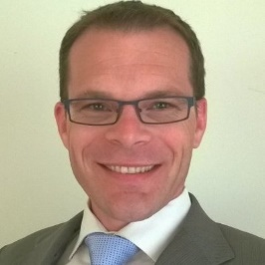 | David Sanguin  Vice President @ Pcubed  https://www.linkedin.com/in/davidsanguin | 
 | Marion Desmazieres  Partner Program manager @ Amazon  https://www.linkedin.com/in/mariondesmazieres | 
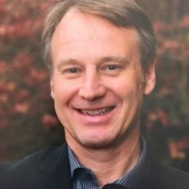 | Benjamin Orillon  Assistant head of School @ FASPS  https://www.linkedin.com/in/benoril | 
 | Anne-Chloe Wambre  Senior Marketing Manager @ Amazon  https://www.linkedin.com/in/annechloewambrepareja
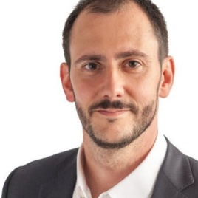 | Alexandre Zanghellini  Cofounder & CEO @ Arzeda  https://www.linkedin.com/in/alexandre-zanghellini-276338 | 

French-American Chamber of Commerce
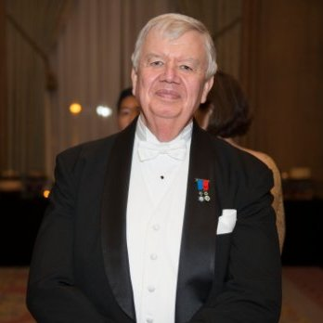 | Jack A. Cowan  Executive Director @ FACC PNW  https://www.linkedin.com/in/jackcowan | 
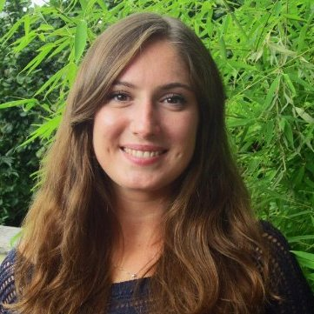 | Claire Bouchot  Trade & Event Assistant (Intern) @ FACC PNW  https://www.linkedin.com/in/claire-bouchot-419b71100/en
PICTURE | Pankaj Parag  Let you add your details, could not find you on LinkedIn
COMPANIES
Claire to provide updated list with logos of companies
Back

(new webpage)
PAST EVENTS
David to provide data
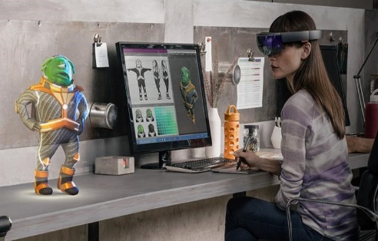 | 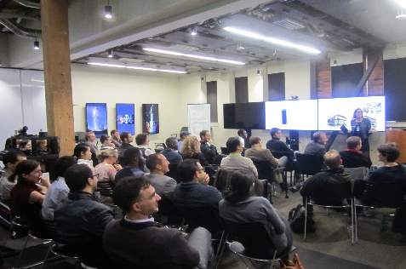 | 
MICROSOFT Research, April 2016  Cutting-edge innovations: HoloLens, Surface Hub, Avatars, Voice Translator, and more.  86 attendees, 38 companies | AMAZON Echo & Alexa, Feb 2016  68 attendees, 25 companies | EXEQUO, Video Games, March2016

# | Date | Location | Theme | Speaker #1 | Speaker #2 | Participants
1 | 2014/09/08 | Microsoft | Cloud Computing | Alain Crozier, President of Microsoft France |  | 30 people
2 | 2014/12/11 | Amazon |  | Eric Broussard, VP international Sales at Amazon, amazon.com and digital innovation | interactive session together around the issue of “Innovation in the IT sector” where each participant is invited to participate by giving a personal point of view or sharing he’s professional experience and ideas on this topic and related ones such as Internet Of things, Cloud computing, or New Form Factors devices
3 | 2015/06/03 | Exequo |  | Stephane Bonfils : story, position in the video games industry, demonstration of one of its last project
4 | 2015/11/12 | Amazon |  | Gilles Belin, Sr. Manager, QA & Engineering Service in the Alexa team will give a talk –en français– about the launch of Echo, Amazon’s hands-free device, and will do a quick demo of Alexa, its cloud-based voice service. | Beatrice Geoffrin, Director Product Management at Amazon, will also give a short talk about her international career and the Amazon culture around embracing risk | 68 people  25 companies
5 | 2016/04/21 | Microsoft Research | Discover cutting-edge Innovations & Technologies from Microsoft Research Scientists. | Hololens - LOOOK | http://www.innovation-committee.com/ | 86 people  36 companies

Pictures available at : https://get.google.com/albumarchive/111688915483079302198/album/AF1QipPZU5WjDqNHcNm1TjayE4rE_sVttJ0llIQPTfOm?source=pwa

Ben, could you give us the access or send the picture saved @:
https://studentfasps-my.sharepoint.com/personal/benjamino_fasps_org/_layouts/15/acceptinvite.aspx?invitation=%7B363A7D1B-723A-4153-BBE9-26492D6D812E%7D&listId=cb37f48c-24c1-4753-b422-5844325202a8&itemId=aba8512a-00c6-4e8d-a98d-e52c58ca3a5a
Pictures Amazon 2015:
Sent in v3

Back

CONTACT US
Use trade@faccpnw.org Email
Enlarge text box like below
Name: xxx | Email: xxx
Subject: xxx
Text

Update address and telephone as below
2200 Alaskan Way, Suite 490
Seattle, WA 98121
Tel: (206) 443-4703 | Fax: (206) 448-4218
info@faccpnw.org
Back

